

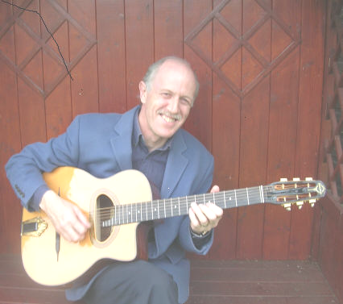

Gypsy Jazz
- ‘Suite Django’-

Paul Vernon Chester
Superb Soloist!

Nick Mellor
Rhythm Guitar!
Astounding Artistry!


Paul Vernon Chester - Wizard of Walsall

Best of Manouche Swing - Jazz on Cue!
ADMISSION £10 - Concessions £9
Thame Snooker Club, St Andrews Court, Wellington St, Thame
Tickets – from Jazz-Eddie 01844 353117
or Email wee-skirl@mcjazz.f2s.com
or www.WeGotTickets.com
More Info Visit www.jazzeddie.f2s.com
Seriously Keeping Live Jazz Alive – please add your efforts!

