

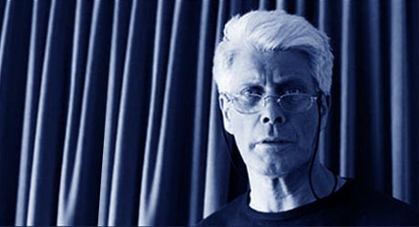

J J Paul Sony Artist – Jazzy Blues Guitar
& Great Gruff Vocals!

Jake Kirkpatrick
Backing Vocals
& Electric Bass!

Thinking Mans Blues – Donald Fagin meets Tom Waits
Music to start your Weekend in the Right Groove.
Feed on the Premise of the Blues
Every Thursday - 8.30pm - ADMISSION – FREE

Get there Early
Great Food Available
More Info Visit www.jazzeddie.f2s.com
The Black Boy
91 Old High Street, Headington, OX3 9HT
Keeping Live Music Alive – give it your support!

